Chapter 8
Genesis 11
The Tower of Babel

It is good to review briefly the previous sessions. The world and the universe were created in a very perfect state through man’s sin and God’s judgement declined to disorder. This is the opposite of the naturalism which goes from disordered states or more order. Naturalism believes that the universe started from a Big Bang and disorder to become more and more complex with time. The historical narrative in the scriptures is exactly the opposite. The universe was created perfect at the beginning. Sinless man and woman were in a very ideal state with God, a walking-talking relationship that was ruined because of man’s disobedience and sin. That sin of man and God’s subsequent judgment resulted in a catastrophic failure for the universe. Not only did man began to die but also all the universe began to disintegrate-all the animals and plants on the earth began to die and the stars began to burn out in the heavens.
God had maintained the universe in a perfect state from the sixth day of the creation until man’s fall which took place in Genesis 3 through the sin of man. God’s maintenance meant that the stars would not have burned out and man would not have died in this ideal state before man’s sin. But with the entrance of sin, man’s disobedience, into the universe God discontinued His perfect maintenance of the universe. Man’s fall brought a catastrophic judgment on the whole universe, the curse of entropy and disorder, the second law of science.

In spite of this catastrophic judgment on the universe, the universe was not totally and immediately destroyed. The earth was still a very beautiful world that man lived in, even though he had the seeds of death instilled in him. All of us, if we die a natural death are dying slowly as do the animals and plants. In fact, all creatures still had a very good world to live in after the fall. There were no polar regions as indicated by the index fossils in all the geological layers up until the last layers, the Pleistocene. The habitats of the present descendants of these pre-Flood kinds indicate that life around the whole pre-Flood world had a very moderate climate. Men and women were living in that very pleasant environment after the fall. Did they learn from the first sin of their parents, Adam and Eve? No. In the pleasant environment with long lives, they forgot the terrible consequences of sin in the fall. They lost their contact with God and descended beginning with Cain into a world of murder, sexual immorality, and violence.

God bore with long suffering this descent of mankind into an irreversible spiral of sin. This led to the second judgment of God, the Noahic Flood and the destruction of the whole face of the earth, all of the land animals and the birds that existed were wiped out except those on the ark with Noah. As Noah and his sons and their wives emerged from the ark, the world was a lot different than the world was when they entered the ark. Now there were polar regions and massive, raging snow storms developing into the Ice age. The sea which was small and warm before now became very large and cooling down. There was tremendous volcanic action, caused by the tectonic activity, pumping a lot of ash into the air which clouded the sun. Snow storms and glaciers were coming in from both poles.

The world that Noah and his family found after leaving the ark was very harsh, much harsher than the world that they had before. Gone was the atmosphere with the higher pressures which allowed the big animals to live. The earth was no longer lush so that people could grow crops in mild conditions and live easier. Their health and longevity of life were gone. Gone were the waters above that protected them from the radiation. It was a very different world, very unpleasant compared to the one before the Flood.

A person would think that man would have learned something. Two sins with the severe consequences of God’s judgments should have been paramount in the minds of Noah’s descendants. Do not sin! Do not sin! The sin of Adam and Eve caused the great catastrophe on the universe. Then the sin of all of antediluvian people resulted in their deaths and the destruction of the known earth. Well, one might ask, "How would they have known about Adam and Eve?" Because Shem would have known Lamech, his grandfather, and Lamech knew Adam. So, at the time of the flood, a person like Noah would have known the things taken place from the time of Adam and Eve only second or third hand. When Noah and his family came out of the ark, they were only 8 people left alive and they somewhat trapped by the increasing ice age in the hottest place on the earth around Babylon. Modern day Baghdad, the hottest capital in the world, is not very far from future Babylon is and future Nineveh was not very far away either. The ark landed near the warmest place on the face of the earth.

Noah and his family all spoke the same language that all of the antediluvian people spoke, probably a Semitic language like Hebrew. Having children, the family of Noah began to increase rapidly. However, there is going to be one more major catastrophe that is going to take place and it is again the consequence of man’s sin. Again, man seeks to exalt himself and to fix his own destiny apart from God.
Men take God’s mandate of human government after the Flood and turn their government into "one world rule" without God. This is the history of the Tower of Babel in Genesis 11. It is a conflict of God's kingdom versus man's government. At the Tower of Babel, we have the first attempt to establish one world government. Before the flood of Noah, man had no governments. There were no police forces, no courts, no kings, no queens, no presidents, no parliaments, and no congresses. Before the Flood, it was a time of the rule of man's conscience without governments. God had not yet ordained governments. After the flood, God established the Noahic covenant including human governments. God gave man the rights of government with criminal laws to maintain justice rather than personal vengeance such as blood for blood. If a man shed a man's blood, his life was to be taken from him by the justice of human governments. However, man sought to use this divine right and privilege to usurp God's kingdom with one world government run by men.

Genesis 11, verse 1 and 2, "Now the whole earth had one language and one speech. And it came to pass, as they journeyed from the east, that they found a plain in the land of Shinar (it is an old term for Babylon or Babylonia), and they dwelt there." "Then they said to one another, 'Come, let us make bricks and bake them thoroughly.' They had brick for stone, and they had asphalt for mortar." Genesis 11:3. "And they said, 'Come, let us build ourselves a city, and a tower whose top is in the heavens; let us make a name for ourselves, lest we be scattered abroad over the face of the whole earth." Men are all unified at this point, they are one big family, speaking one language. They are all descendants of these three sons of Noah. Noah himself is there with them.

"But the Lord came down to see the city and the tower which the sons of men had built, and the Lord said, 'Indeed these people are one and they have one language, and this what they will begin to do; now nothing they propose will be withheld from them." Genesis 11: 5-6. Noah lived almost to the time of Abraham and Shem may have outlived Abraham. So as strange as it may seem, all of Noah’s descendants, Shem, Japheth, Ham and all their descendants, are here at the Tower of Babel. They have come down to this plain of Shinar, well-watered by the Tigris and Euphrates Rivers with no rocks there. As in the time of Nebuchadnezzar, the king of Babylon, everything must be made out of mud and bricks since there are not stones there. The only stones that are found there have been imported. For instance, in Nebuchadnezzar’s buildings the only stones are at the base of the doors as turning posts for the doors. These stones as turning posts for doors are inscribed with the name of the building.
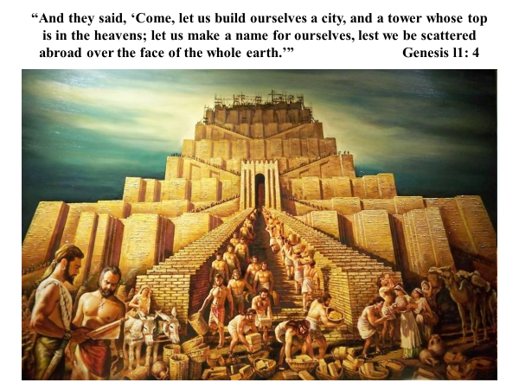
At the Tower of Babel men do not have stones to build with, so they bake bricks out of clay and they use asphalt for mortar. Noah, Shem, Ham, Japheth, and all of their descendants are there. Did they know what happened at the Flood and why God brought the Flood on the earth because of men’s sing? Sure they did, all of them did. But they came together and said, "We are going to make a great name for ourselves, we're going to work together." What is God's evaluation of this? It is sin. Why? What is their sin here? Men are going to make a name for themselves, not for the great name of God. They are going to build a tower to heaven.
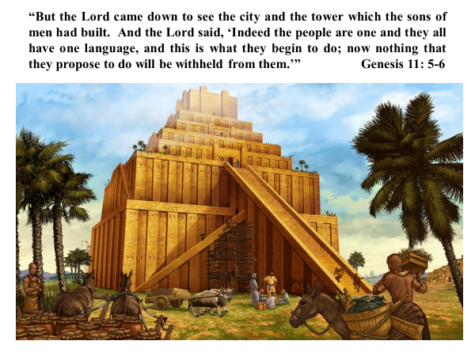
God comes down and says that there is nothing that men can not accomplish if they are united. If mankind is united, they will be able to exalt themselves in sin and they will become the center of what is not right. Is this tower to worship God? No! Are they going to do honor to God as the creator and as their Lord. Are they going to worship God as the one who saved them as descendants of Noah from the destruction of the world and from the giants and the others before the Flood? No! All sin in its essence is saying, "I will, for myself, become great." It was a sin of Satan, it was a sin of Adam and Eve, it was the sin of the people before the flood and it resurrects its ugly self in the same thing that is going to happen here at the Tower of Babel. All mankind is gathered together to build this tower but God judges that it is not going to happen.
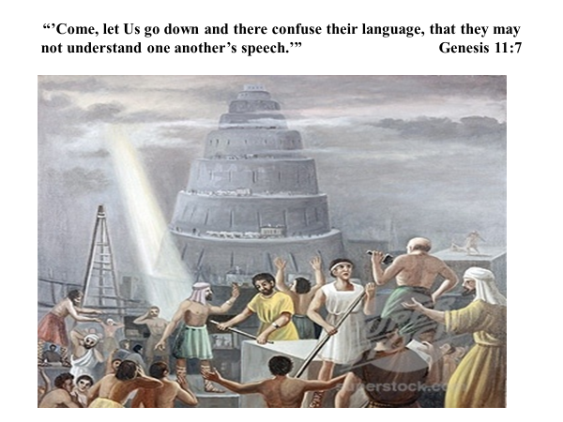
God is going to eliminate their common language and to divide mankind by causing them to speak many languages. "Come," God says, “Let Us (again God speak in the plural, the Trinity woven all through this thing as in the Genesis creation "Let Us make man in our image”). "Let us now go down and confuse their language, that they may not understand one another's speeches." God uses the divide and conquer strategy to punish man’s sin. "So the Lord scattered them abroad from there over the face of all the earth and they ceased building the city." Therefore, the tower is called Babel. The name Babel is like the word “buzz” is for the sound that bees make. The name “Babel” comes from the sound, “ba ba ba ba ba”, which men hear when listening to someone speaking a foreign language. Romans heard foreigners speaking a different language and their speech sounded like, “ba ba ba ba ba”, so they called the foreigners barbarians. The tower of Babel means that their languages were confused.

The Lord confused the language of all the earth and from Babel the Lord scattered them abroad over the face of the earth. We did not get our languages from evolution, from primitive grunts to sophisticated languages. Beginning at the Tower of Babel mankind was given good and complex languages. Every language on the face of the earth is more primitive today than it was a thousand years ago. Each language has lost a lot of its grammar and structure. Some have lost a lot of their vocabulary. God makes everything good even languages in the beginning. In spite of man’s sin at the Tower of Babel, God made man’s original languages very sophisticated, very complex and very beautiful.
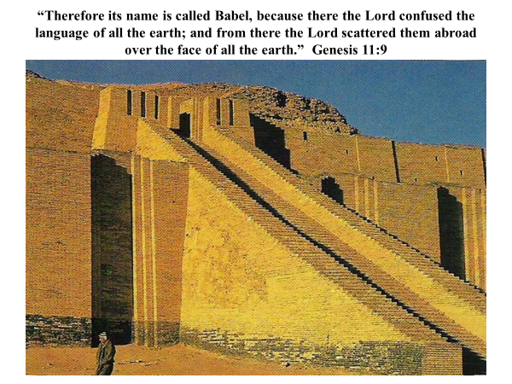
Our human languages did not evolve upwards but they have devolved from sophisticated languages at the Tower of Babel, the inverse of the naturalistic storyline. The naturalists say that all men were primitive-barbarians and cave men and that men developed the sophisticated languages over time. The scriptures teach the opposite. Men got their language because of sin at the Tower of Babel but God made languages very sophisticated at the Tower and the languages have been going downhill ever since.
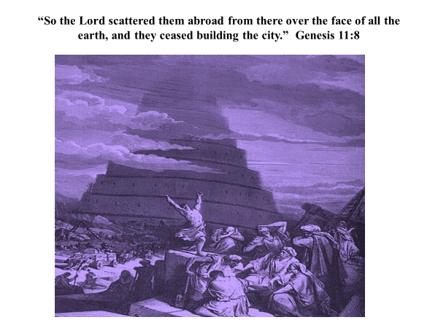
The confusion of languages at the Tower of Babel divided mankind. This is an old rendition with the Tower in the background.
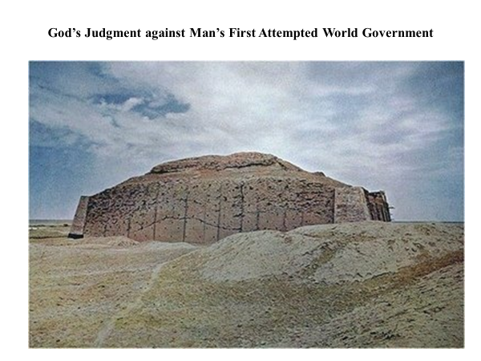
In the plains of Babylon men in the ancient past built towers like the Tower of Babel. They are called ziggurats and there are a number of them in the Tigris and Euphrates river plains. Evidently, these are later miniature duplicates of the Tower of Babel, feeble attempts to resurrect the Tower by peoples divided by different languages.
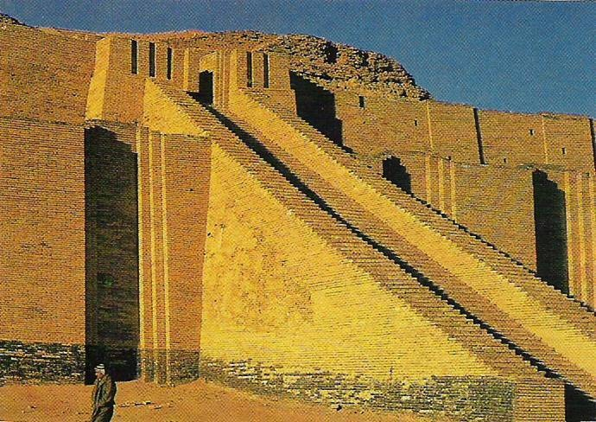
This is modern reconstruction of the Tower in Babylon to resurrect the past glory of man’s attempt at a one world government to the glory of man. Men fail to acknowledge God’s judgment against man’s first attempt to glorify mankind under one world government using one world language. At the Tower of Babel, you have God’s division of man by languages and subsequent “races” as the naturalists claim. However, there is no basis for racism because we are really all descendants of Adam and more explicitly, descendants of Noah. Men are divided into “races” by naturalistic evolution. No “race” can say that they are superior. Rather, God divided families at the Tower of Babel by languages. This division of families gave each language group a distinct gene pool of facial features, skin color, and body characteristics. Naturalists attribute these bodily characteristics to different evolutionary “races.” However, all people on the face of the earth are all genetically related through Noah and his sons. All people can marry as members of the human kind and were only divided by God at the Tower of Babel by languages.

Adam and Eve were created with perfect, rich, and unmutated genes from which all of mankind is descended. Because of unmutated genes, Cain, their son, could marry any of the daughters or other female descendants of Adam and Eve. With the protection of the water vapor canopy, mankind probably had very few genetic mutations in the human genome, human DNA, before Noah. Mankind since the Flood has gotten all of their genetic information from Noah and his wife. With the division at the Tower of Babel this genetic material, human DNA, was narrowed into each language group to what the parents of that language group possessed. Later generations had a multitude of combinations of the familial genes. Apparently, because of the limited mutations in the familial genes, intermarriage in that language group did not lead to genetic defects. A person could marry a close relative such as a first cousin or even a sibling without defective off spring.

For a time after the Tower of Babel, there were no laws against close marriages such as a law of incest. Even at the time of Abraham, he married Sarah, his half-sister. But the genetic mutations and defects increased with time so that by the time of Moses and the giving of the Law the genetic mutations had multiplied as accumulated genetic load in the different language groups. Therefore, the Mosiac Law forbids incest, the close marriage to immediate family members. Families in distinct language groups who do not enforce laws against incest suffer from increasing genetic defects in their offspring.

Since all mankind is descended from Noah, the descendants of his son Shem have Semitic languages, the descendants of Japheth speak Indo-European languages, and the descendants of Ham utilize diverse Hamitic languages. All languages of mankind were created by God at the Tower of Babel and these languages divide mankind into three basic language groups according to the sons of Noah. Mankind are divided by their languages, not “races.” God used the division of mankind by languages for what purpose? To keep man divided and to prevent idolatrous worship of themselves. God saw what would happen if men were united. Men would use their unity for evil intents. Contrary to God’s intent and judgment, men since the tower of Babel have constantly been trying to unite all people through large governments, whether is kingdoms, empires, caliphates, etc.
More recently, men have made many efforts to form one world government. I was reading a book recently on Einstein that the biggest thesis in his thinking was that if the world had one government, there would not be national conflicts and wars. The globalist promote the one world government as the solution to world peace. In reality one world government only leads to one world power for those that are in control of it. It has always led to evil as the historical efforts of the Romans, of Islam by Mohammed, of Mongols by Genghis Khan, of world communism by Stalin and Mao, of Nazism by Hitler, and others. Have you ever seen a big government or an empire, or caliphate or czar that was good? They all turned bad with myriads of dead in their wake. And their dynastic heirs are worse. The longer their governments last the worse their subjects experience.

There is a story told about a man in history that is known as the tyrant of Syracuse. Syracuse is an island off of Italy. This tyrant of Syracuse came in one day into a temple. I do not remember to which god the temple was dedicated to. In the temple was a woman, down on her knees praying to the god and saying, "Protect our ruler and keep him in good health." The tyrant had never heard of anyone pray that way because they all hated him. He walks up and comes around in the front of this woman and he says, "You are praying for me?" She says, "Oh yes," She said, "Before you there was a ruler two rulers before you and he was an evil man, a wicked man. And I came and prayed to the god and he took him away and put another ruler in his place but he was worse than the previous ruler. So, I came and I prayed that the god would get rid of him, and the god took him away. And now you have come and you are worse than the first two rulers." She continued, "If I pray that the god will you away, another worse than you will come. So I'm praying for your good health." So is the lineage of rulers, especially those striving to make themselves world rulers.

Since the Tower of Babel it has been man's intent has been to get back to one world government where man is his own ruler. Look at the communists and the socialists today. They are professed or practical atheists who believe, "If God exists and is really good, he would not have set up a world like this, with oppression, greed, crime, poverty and all forms of social ills and evils. We are going to set up a government and we are going to eliminate all of these evils. We are going to do what God can or will not do." All of them, whether Hitler, Stalin, and Mao with their followers are all the same. They are atheists, believing God does not exist, is impotent, or uncaring, and they, as saviors of the world, are going to set up a world government that is good for everybody, a utopia on earth.
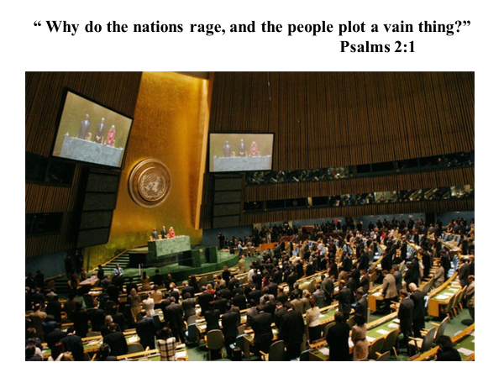
Psalms 2 however, describes the futility of this effort of mankind. "Why do the nations rage, and the people plot a vain thing?" This is a picture of the United Nations as in Psalms 2, beginning in verse 1. "Why do the nations rage and the people plot a vain thing?" "The kings of the earth set themselves, and their rulers take counsel together."
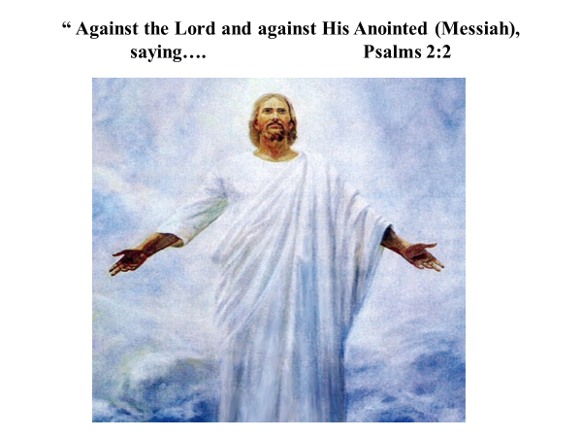
"Against the Lord and His anointed (in Hebrew that's the word Messiah) saying... Let us break Their bonds in pieces!"
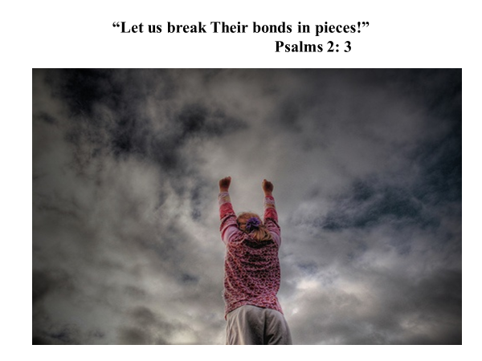
That is what men today are saying "And cast Their cords from us" “His name shall fall.”
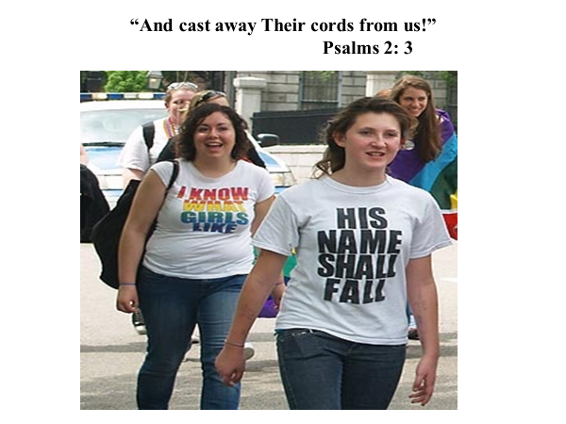

But speaking about God in verse 4, "However, he who sits in the heavens shall laugh,"
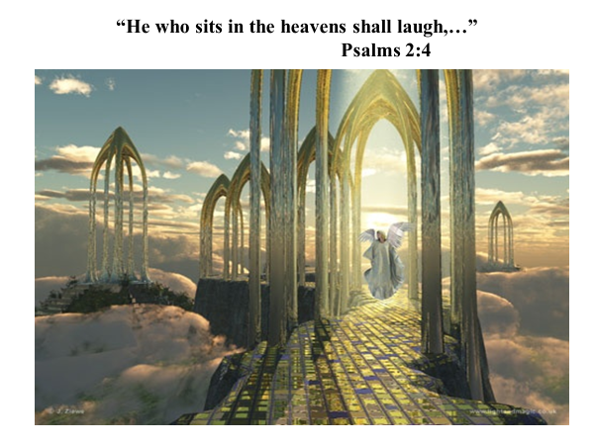
"The Lord shall hold them in derision,"
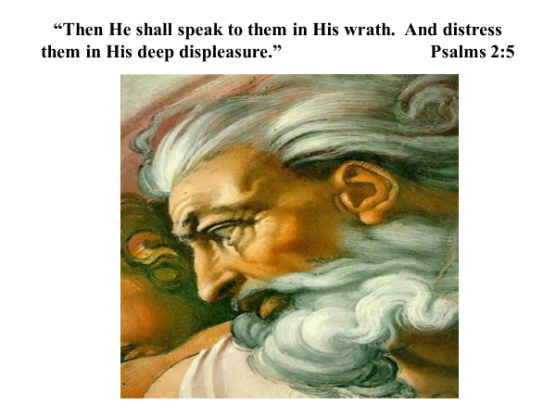
"Then he shall speak to them in His wrath. And distress them in His displeasure." This is the Lord's coming back at them for their rebellion and their anger at him and his Annointed.
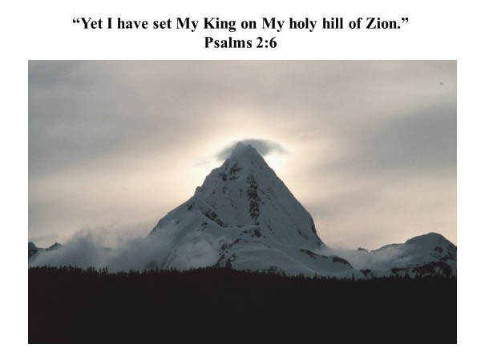
"Yet I have set my king on my holy mountain of Zion" "I will declare the decree (In other words he's going to set, and this is going to take place): The Lord said to me, you are my son today I have begotten you." Who is He talking to? God, the Father, talking to His son.
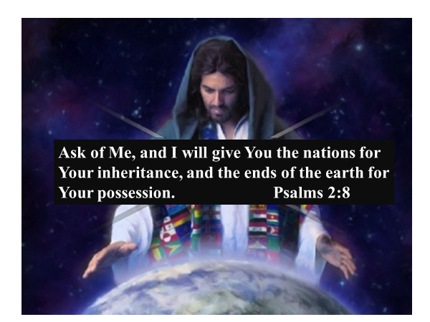
"Ask of me and I will give you the nations for your inheritance and the ends of the earth for your possession. And you shall break them with a rod of iron and you shall dash them to pieces like a potter's vessel."
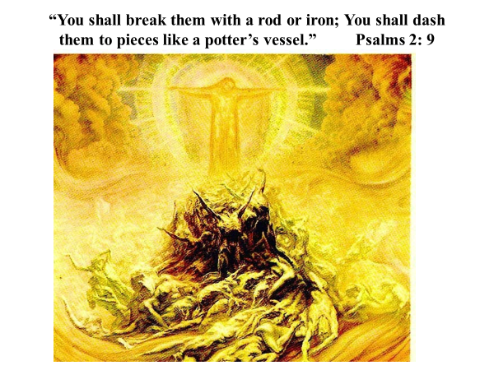
What is happening here? Would anyone do that to His heritage? What is He inheriting? If God's giving His Son the nations, does he beat them with a rod and break them like a potter's vessel? Yes. Why does he have to do that? Because of their evil and wickedness as nations. When will this take place? I will take place in the future according to biblical prophecies.
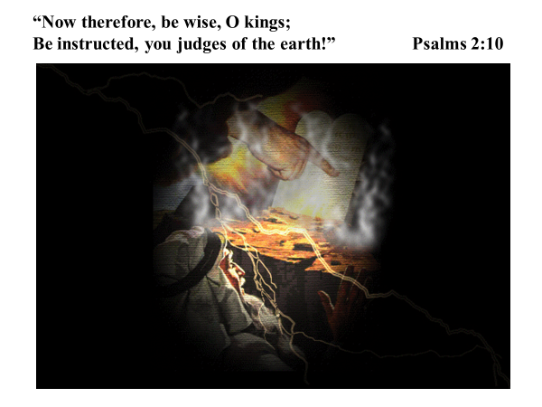
"Therefore, be wise O kings (see the wiseman looking up to what God is decreeing with His hand). Be instructed, you judges of the earth!" Verse 10.
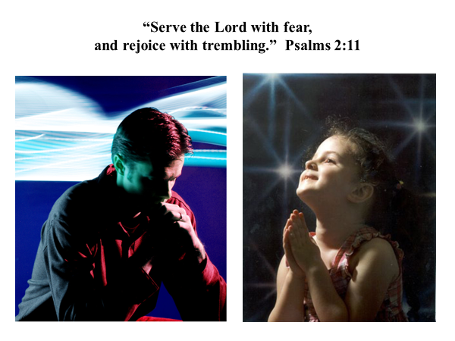
Verse 11, "Serve the Lord with fear and rejoice with trembling." Remember what the book of James says, "The Lord gives grace to the humble" And so we bow to him in prayer and in pleasantness with trembling we look to him.
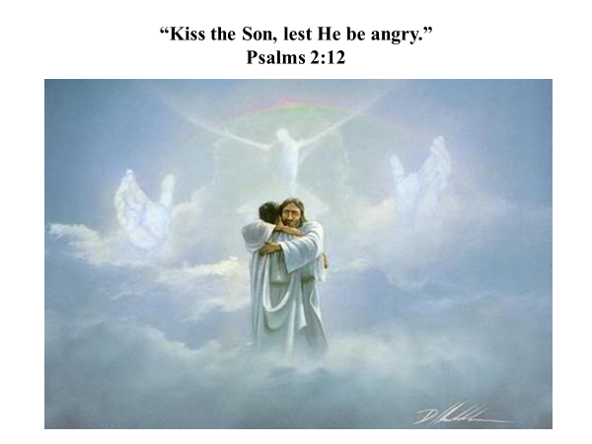
"Kiss the Son, lest He be angry," verse 12. The command is: You nations of the earth turn and kiss the Son. This is in the Old Testament, Psalms 2. See the Trinity again?
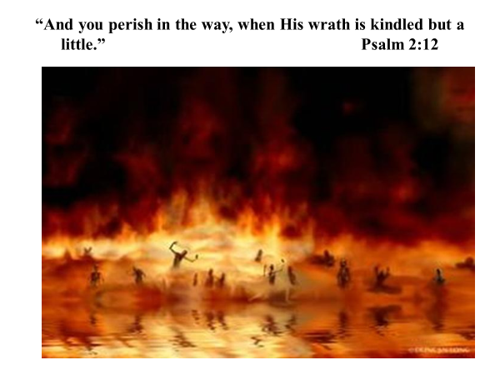
"And you will perish in the way, when His wrath is kindled but a little," If men do not want to kiss the Son, then they will perish.
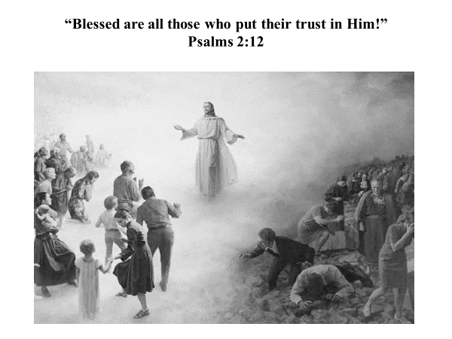
"Blessed are those who put their trust in him," Remember what Christ said on the Sermon on the Mound? Those on His right are blessed, and they entered the Kingdom. These on His left, where do they go? He says, “Depart into the lake of fire prepared for the devil and his angels.” Men and nations can revolt Him or they can embrace Him. God reveals His plan for the nations and His eternal kingdom. Even more of God’s eternal plans are revealed in the books of Daniel and Revelation. Man's plans are the recreation of the Tower of Babel: unified mankind under one world government. God's plans however for the nations are delineated in Daniel 2 and 9. God's ultimate plan for mankind in the end, is the establishment of His eternal kingdom in Daniel and Revelation.

In Daniel 2, God reveals the great world governments through Nebuchadnezzar's dream in Daniel. When the king of Babylon saw this vision, it shook Nebuchadnezzar. He was probably the most absolute ruler that the world has ever seen. Even when he was insane for seven years, no one overthrew his kingdom. His kingdom was so secure that he could resume his reign after seven years of total insanity, probably because he had Daniel, a great and godly wise man, running his government during his absence.

This dream so shook him that he called the wise men to interpret the dream. His wisemen said, "Tell us the dream and we'll tell you the interpretation." And he says "No, you tell me the dream and then give me the interpretation." He wanted to make sure they were not going to trick him. They said, "No one has ever demanded that, we can not tell you the dream, only the gods can do that." He says, "If you do not give me the dream and tell me its interpretation," he says, "I am going to have you all executed." Because they can tell him the dream, The king of Babylon orders the execution of all of the wisemen in Babylon. Daniel as one of the wisemen asks the executioner what is happening. executed. The executioner explains to him and Daniel asks the king for a little time to seek the dream and its interpretation.
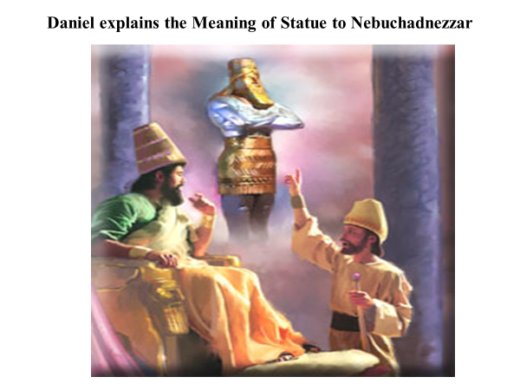
Daniel prays to God and asks his three friends also to pray. God tells Daniel the dream and the interpretation, and this is it.
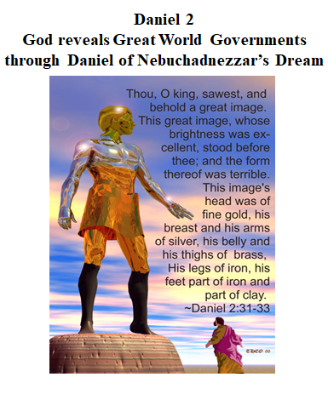
"Thou kings sawest and behold a great image. This great image, whose brightness was excellent, stood before thee; and the form thereof was terrible. This image's head was of gold, his breast and his arms of silver, and his belly and thighs of brass, his legs of iron and his feet part of clay and part of iron.” Daniel gives Nebuchadnezzar the dream and now he is going to explain the meaning of the statue to Nebuchadnezzar.
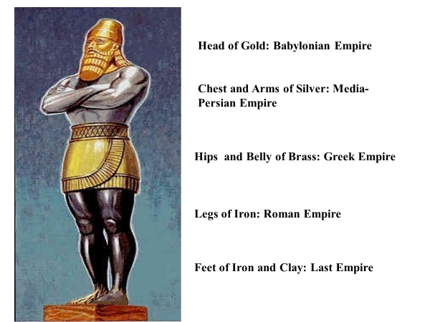

"You O king, you're the head of gold, the Babylonian empire. But after you will rise another that chest and arms of silver, that are inferior to you. The silver chest and arms to be the Medes and the Persians we find out later. The hips and the belly of brass are the Greek empire, the legs of iron the Roman empire and last of all the final empire, which has not yet come is the feet of iron and clay. These are the Gentile kingdoms that will proceed the establishment of God’s eternal kingdom which Christ will establish in the future.

God's kingdom is not made with human hands. God’s kingdom was a stone, taken out of a mountain, and not cut with human hands. It will destroy all of man's kingdoms and be forever according to Daniel 2:44, "And in the days of these kings the God of heaven will set up a kingdom which shall never be destroyed; and the kingdom shall not be left to other people; it shall break in pieces and consume all for the empires and it shall stand forever."
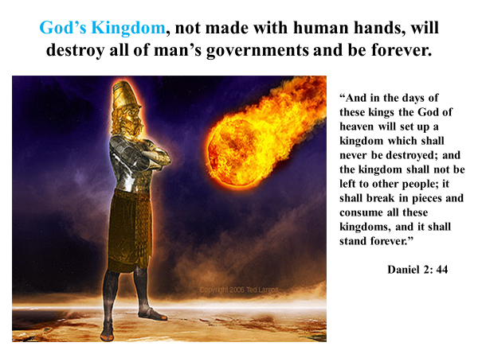
God’s kingdom is the stone which comes and strikes the statue in the feet, destroying the statue and all of its kingdoms. Man’s kingdoms are destroyed and the wind blows them away. God’s kingdom then grows up and becomes an eternal kingdom. Will the Gentile empires stand? No, but God’s kingdom will last forever.
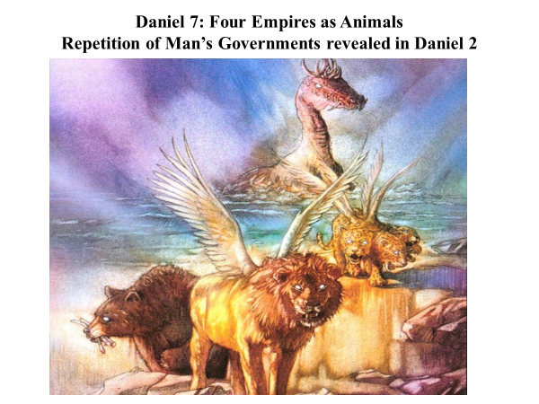
In Daniel 7, there are four empires portrayed as four beasts. Some biblical theologians think that these kingdoms are part of the very last Gentile kingdom but it appears they are a repetition, a reinforcement of man's kingdoms that are revealed in Daniel 2.

John's revelation talks about the destruction of the human governments and the establishment of God's government as promised in Psalms 2. At the end of the book of Revelation, Christ, the Messiah and Son of God, comes as a warrior to destroy the nations gathered against Him. God distresses the nations and their rulers that have who have revolted against him, speaks to them in His wrath. In Revelation 19 at the battle of Armageddon Christ comes with His saints to destroy the Gentile nations and to set up His kingdom. He has given the nations time to repent between his first and second comings. For centuries men have revolted against God and put their hope in human governments. The nations have gathered together in the valley of decision and they are going to rise up to fight against Him in the battle of Armageddon but they will not succeed.
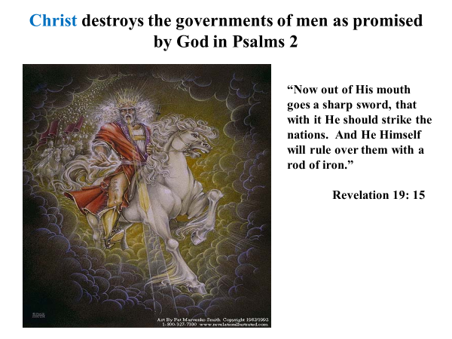
God will establish His Son and His kingdom forever. His Son will dash the nations to pieces like a potter's vessel and will rule the nations with a rod of iron. God has given the nations and their rulers full warning to kiss the Son.

In John's Revelation 12: 9, Satan is revealed as the power behind human governments and has a satanic realm of fallen angels to carry out his battle against God and His angels. In the book of Daniel 10, an angel comes to give a message to Daniel but he was held back from his mission for 21 days. Why? He says, "The king of Persia resisted me and I could not get here until Michael came and helped me, the archangel over your nation.” Later the angel says, "Afterward I have to go and battle with the king of Greece." Is he talking about humans there? No, Satan is the real power behind these evil angels which control the human rulers, but Satan will be vanquished in the future.
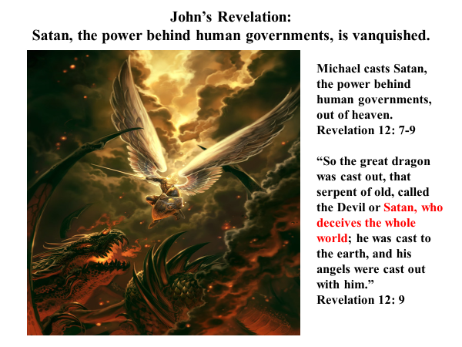
Michael this powerful angel will cast Satan, the power behind the human governments, out of heaven with his angels. It says, "So the great dragon was cast out," "So the great dragon was cast out, that serpent of old called the Devil or Satan, who deceives the whole world." He is the power behind these human governments that offer great things to mankind but Satan is deceiving the nations through these governments. Satan is cast to the earth and his angels are cast out with him. Christ destroys the governments of men at the battle of Armageddon as promised by God in Psalms 2. "Now out of His mouth goes a sharp sword, that with it He should strike the nations. And He Himself will rule over them with a rod of iron," Revelation 19:15, just as the Psalm 2 promised.
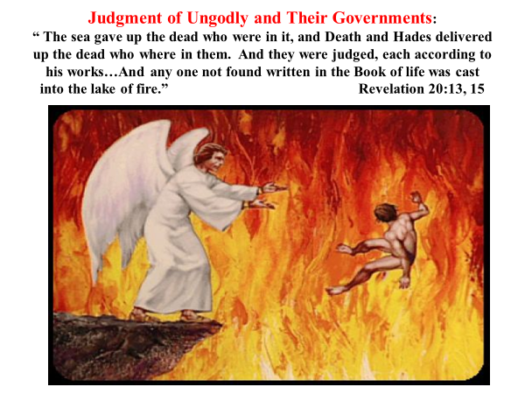
The final judgment of the ungodly and their governments if not only frightening but very final, "The sea gave up the dead who were in it, and Death and Hades delivered up the dead who were in them. And they were judged, each according to his works... And anyone not found written in the Book of Life was cast into the lake of fire." A terrible destiny.
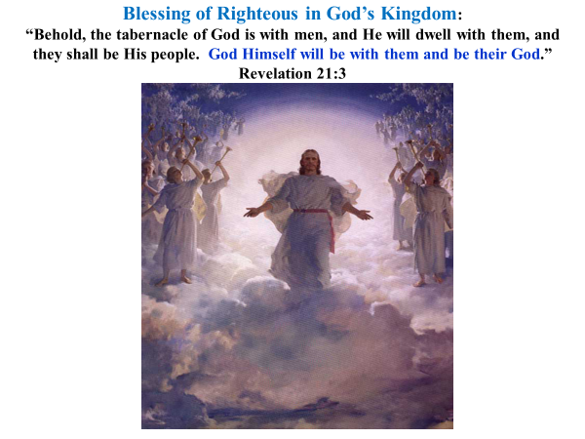
But there's a blessing for the righteous in God's kingdom as opposed to man's kingdoms. "Behold, the tabernacle of God is with men and he shall dwell with them and they shall be His people. God himself will be with them and be their God," Revelation 21:3. 21:4.
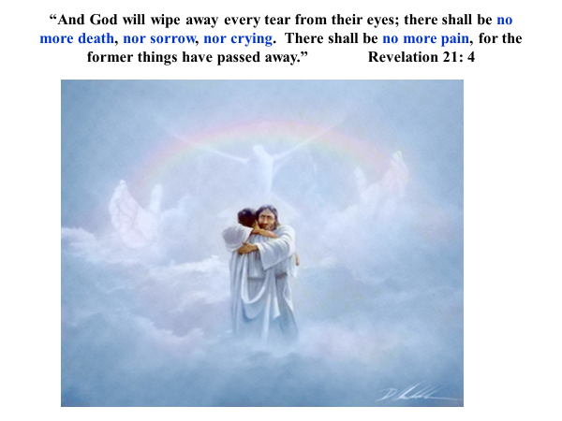
"And God shall wipe away every tear from their eyes; there shall be no more death, no more sorrow, no more crying, there shall be no more pain, for the former things have passed away." Kissing the son.
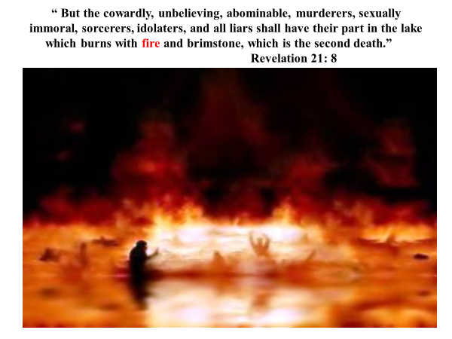
"But the cowardly, the unbelieving, the abominable, the murderers, the sexually immoral, the sorcerers, the idolaters, and all the liars shall find their part in the lake that burns with fire and brimstone, which is the second death." Terrible destiny, but I do not want to end on that.

Remember what was told the nations in Psalm 2? Kiss the Son, O nations, and enter into God's Kingdom! The alternative is laid out in I Corinthians 6: 9-11, "Did you know that the unrighteous will not inherit the kingdom of God? Do not be deceived, neither fornicators, nor idolaters, nor adulterers, nor homosexuals, nor sodomites, nor thieves, nor covetous, nor drunkards, nor revilers, nor extortioners will inherit the kingdom of God. And such were some of you. But you were washed, but you were sanctified (that means to be made holy), but you were justified in the name of the Lord Jesus and by the Spirit of our God." The hope in other words is that, if the nations will listen and they will give heed to God’s warnings, they will not share this destiny with Satan and his angels in the lake of fire. What must the nations do? They must come to kiss the Son and say, "You are the One that makes me holy, and you are the One that will get me into Your kingdom." Otherwise, men will share in the same revolt that our ancestors partook in. It does not matter what nation a man is from, we all are sons of Noah.

All men and women have two destinies. We can revolt against God and follow in the sins of Adam and Eve and most of their descendants before the Flood and in the sins of the descendants of Noah at the Tower of Babel. But for all men and women who follow this revolt and sin against God, their destiny is fixed. The lake of fire, prepared for Satan and his angels, is already prepared and burning, even hell itself will be cast into the lake of fire. All mankind will share in that destiny because of our revolt and sin against God unless we come to the Son who can take away our sin and its death penalty. The Son by His blood sacrifice can make us holy, even though we are not holy people by nature. The Son came into the world to undo the sin and Fall that began in Genesis 3. Paradise was lost but the Son won paradise back for those who repent and turn to embrace Him. His redemption and kingdom will last forever. Those embracing the Son never lose it again. His eternal kingdom is offered free to all men who are willing to kiss the Son.

