Chapter 2
Genesis 1-2:
The Creation-Part I

We are going to take a journey in this series on Genesis 1-11 back in time and space to visit the origins of life and to the origins of the universe. In this journey, you have to realize there are certain constraints when you travel back through time. The entire universe is made of only two components matter and energy. The basic laws of science define the interactions of matter and energy. So our trip back in time to the origins of the universe and life will be a trip in time through the matter and energy of the universe.

The laws of science put certain constraints on us. One of them is that you have to understand that the universe never gains or loses any matter or energy. This law is called the first law-the law of conservation of matter and energy and it is seen in the graph below. So, a thousand years ago, the universe had the same amount of matter and energy that it has today and a thousand years from now, if it continues, it will have the same amount of matter and energy as it has today.

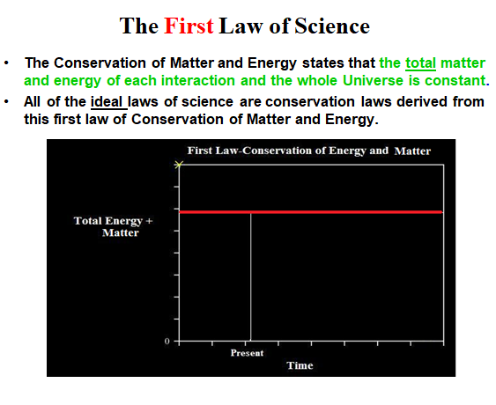

The only difference is, as time passes, the matter and energy of the universe is always in a state of flux. The matter and energy in the universe is always changing. Although the total quantity of the matter and energy in the universe is constant, the configuration of matter and energy is always changing. The same amount of matter and energy that you have today does not have the same configuration that it had yesterday. It has been rearranged from yesterday. Tomorrow, its configuration will be different than today for the same matter and energy.

Since the universe always has a constant quantity of matter and energy as it changes with time, the universe has a continuity of matter and energy interactions in time-never losing or gaining matter or energy in time. This uninterrupted continuity of matter and energy interactions/events gives science a rule called the Law of Causality of cause and effect. Most people think that the Law of Causality is a product of logic in philosophy. But it isn't. Rather the law of cause and effect is a constraint on the way the universe operates in time with a constant amount of matter and energy. So that at any given moment in time, there's a cause-the arrangement of matter and energy in the universe. At an instant of time later, there is an effect-the subsequent arrangement of the same matter and energy in the universe. Then, this effect becomes in the next instant in time the cause of another arrangement of the same matter and energy in the universe. So the universe has a continuous sequence of causes and effects through time.

In this book we are going to follow this law of causes and effects in the universe back in time to original causes-the beginning of life and the beginning of the universe. We are going to follow several simple rules in this journey back in time. First, there is this law of causality, for each effect there is always a preceding cause. Second, this is the first law of science that there is always the same amount of matter and energy in the universe. The universe has a constant quantity of matter and energy. This law is one of the two fundamental laws of science which we will study later in this book. Third, even though the quantity of matter and energy in the universe is constant, there is the second law of science that matter and energy always lose net order in matter and energy interactions. As matter and energy goes through this time continuum of matter and energy of the universe, something happens with them. Matter and energy lose their quality of order. Matter and energy in the universe are like a big stream up on a mountain as it goes down to the sea. They cascade down and down and down with time. Just as the water travels from the tops of the mountain down to the sea, no quantity of matter and energy in the universe is lost in its downward cascade of order over time. Just as the cascading water loses its useful energy, the quality and order of matter and energy in the universe decrease as matter and energy flow through time. So according to the second basic law of science, in every interaction of matter and energy in the universe there is a net loss of order.

For instance, let me give you an example: my clothes. I have a favorite red sweater that I often wear, I won't wear forever, because every place I go, I leave a little of it here and a little of it there. Pretty soon I am down, as we used to say in the 60's, "man you're down to your threads.” Our cars sitting outside, as we sit here, have rust falling off of them. As we drive home, rust will continuously fall off of our cars. Our cars had their finest day when they rolled off the assembly line. Eventually, there won't be any of our cars left. All of their rust and lost parts will still out there somewhere. But what happened to our once beautiful, new cars? They have gone to disorder.

Our sun, gigantic amount of matter and energy is one star of probably 200 billion in our galaxy. There are 100-400 billion galaxies in the visible universe, each with an average of a hundred billion stars. The reason we can see these stars and galaxies is because they're giving off light. But, they never get that light back and they can not continue to radiate off their light energy forever as the 100 billion stars are doing in the photo below.

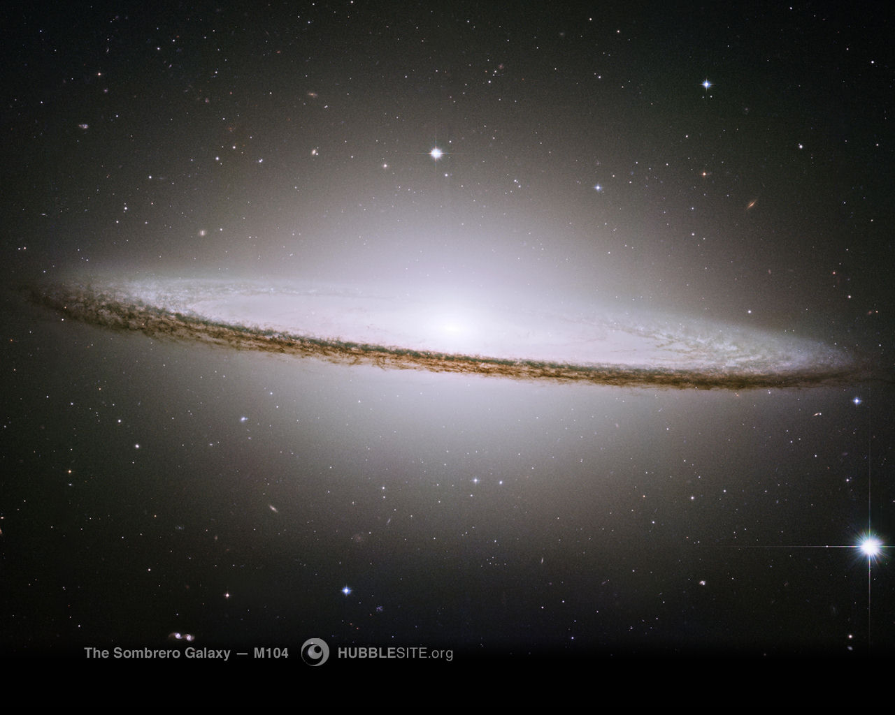

A Galaxy of 100 billion stars Giving off Their Energy into the Universe

Because of the first law of a constant amount of energy and matter in the universe, there is no net loss of energy and matter in the universe as the stars in galaxies lose their matter and energy because their radiated energy and matter are spread throughout the universe. What matter and energy the stars and galaxies lose, the deep space of the universe gains. But as a consequence of a constant hemorrhage of energy and particles into the deep space of the universe, the stars in the galaxy will eventually burn out forever.

So over time there is a continuous spreading and disordering of matter and energy in the universe. In this continuum of cause and effect, matter and energy in the universe constantly loses order over time. So in our journey back in time, we will see that yesterday we had a more ordered universe than we have today. Our sun had more matter and energy yesterday than it has today. And as you go back to the day before, it had more energy then. But this process backward in time can't continue forever. Traveling backward in time, the universe can not forever be getting more and more order. Also, traveling into the future, the luminous celestial systems in the universe can not continually keep burning forever. The stars and galaxies in the universe will eventually burn out, either in explosions such as novas and super novas or in slow burnouts.

So, in this journey back in time, you have to remember there are certain scientific rules that guide us as we travel, as we are going back to the origin of matter and energy in this study. These scientific rules apply to time travel in the universe, whether we are supernatural creationists or naturalists. The naturalists have one problem in going back to the origins of the universe as we are going to see. The universe can not create one gram of matter or destroy it, it can't create one joule of energy or destroy it. So we come back to a point in the past where the universe began, where the universe had the same amount of matter and energy as it has today. Where did the matter and energy of the universe originally come from if the universe can not create or destroy its matter and energy? That is one of main issues which we hope to visit using the laws of science in our trip back in time.

In Genesis 1 and 2 we're going to go back to the inception of the whole universe. There are 100-400 billion galaxies that we can see without our most powerful telescopes. As seen in the deepest field Hubble telescope photos below, we can not even see an end to the galaxies.

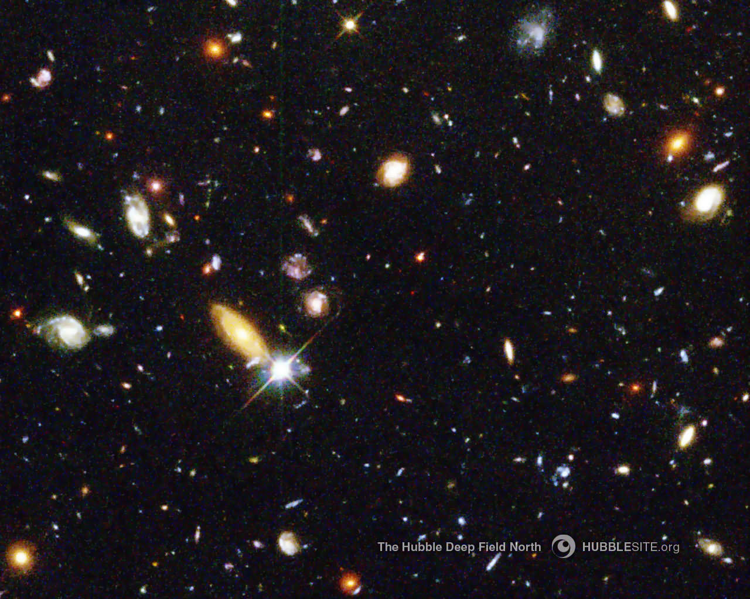

Hubble Telescope- Deep Field Photo

The galaxies disappear off into an infinity of space, but they have not existed for an infinity of time because they can not burn forever. The galaxies and their stars started burning at some point in time and now they are burning out. So we can not go back in an infinity of time even with a universe that extends into infinity in space. But, we can go back to a beginning a finite time ago when the universe came into being and its galaxies and its stars began to burn.

I would like for you to imagine in your minds-What was it like before there was a universe with all of its matter and energy? Let us take a trip back before the matter and energy of the universe existed. Studies were done while I was working in a space program, although I was not involved in these studies. On the earth we have lots of background noise: crickets chiggering, birds, wind blowing. We have lots of input all the time from our five senses. One of the problems we have with astronauts in space is that there is little or no sensory stimulation. Often there is no light, there is no sound, there is no touch, and there is no taste. A person can begin to lose all of his sensory perception. The problem is that an astronaut in a spaceship can at times be without any sensory perception. For instance, if you are in the shadow of a celestial body, even as close to the sun as Mercury but on its back side, there can be total darkness. There is no light except the light reflected back in from other planets. The temperature is almost absolute zero. Mercury is almost stone cold on one side and the other side is hot enough to melt lead.

The space program had a problem: What do we do if we put a man up there and he has none of his sensory stimulations? So they ran tests and they would wrap these guys up in cotton, put them in suit and float them in a pool, where they can't hear, taste, or see. Do you know what happened? They could not get anyone who was able to go past two hours without going crazy. Where would their sensory stimulations come from? From matter and energy interactions, of course.

But, let's go back in our journey back in time. What if there was no matter or energy, before the beginning of the universe. What would it be like? Imagine, total silence, nothing, no light to see with. Nothing to taste, nothing to touch, there's nothing there to create sensory stimulation. It is hard for us as humans to imagine those conditions. But that is what it was in eternity past before the inception of the universe. And you wonder, how could this be? How could any person or personality exist in that type of state of nothingness? And yet as you are going to see, there's a creator to the universe who existed in that state of nothingness for we don't know how long. In contrast to the universe, He had no beginning. He existed in this eternal state with no sound, no light, no nothing, all by Himself. There was no creation, there was no matter and energy, there were not even creations in other dimensions such as angels or other things. Put yourself in this total silence from eternity past. That is where we begin, and that is where Genesis begins-Genesis 1:1. In this world of nothingness of the past, all of a sudden, things began to happen.

Genesis 1 and 2 are the beginning not only of the universe but of life. We are going to see the beginning of the most important law that we have in science, the law of creation. And this first law of science began interestingly enough in these portions of scripture that are most despised by science as being historically and scientifically untrue. Yet the historical events of Genesis 1 are the source of this first law of science. In Genesis 1-2, we're going to begin with the creation of the universe and life. But as we said, Genesis 1 begins with total silence, nothing, no particles, no light, total darkness. Some of you have experienced a little bit of that absence of sensory perception when you're in a cave and they've turned off all the lights and everyone became absolutely still. No matter how long you sit there, you're eyes never get adjusted to the darkness and silence because there is nothing to see, there is no light and there is no sound, even though you can smell the cave. But, in the case before the creation of the universe, there was no sensory perception, nothing but nothingness.

So in Genesis 1:1, into this nothingness, “In the beginning, God created the heavens and the earth.” This is the beginning of the universe. What God is doing here, is described by a word in Hebrew-“bara, to create.” Bara is only used of God creating in the Scriptures. It is never used in allegory or myth. Bara has two possible meanings: (1) God bringing something out of nothing (ex nihilio), which is supernatural because the universe never creates nothing or (2) God molding things. In both cases of creating (bara) God as the Creator does not lose any energy in the creating process and He does not lose any order in Himself. God as the Creator does not diminish Himself in the creation process. God creates and orders the universe in Genesis 1-2 without the instrumentation of factories, tools, or workmen. God only speaks to create the universe with its matter and energy out of nothing and without getting tired or wearing Himself out. Nothing in the physical universe can naturally do either of these functions: bring something out of nothing and then fashion it without losing part of itself or using another energy supply which also degrades the universe.

So in the beginning, God creates the universe by speaking the universe’s matter and energy into being. However, before the first day of supernatural creative acts to fashion and give order to the matter and energy of the universe, the matter was without form and void (tohu and bohu in Hebrew), without any order. So before the six creation days of Genesis 1:2ff in which God gave the universe order, He called into being matter (ex nihilio) in Genesis 1:1.

But as we're going to see, this matter is probably at absolute zero temperature, because you have no light and the matter is without shape or form. Absolute zero degrees temperature is the coldest temperature that matter can exist at. There is no temperature below absolute zero. That is the temperature at which matter has no energy to give off. We can get very close to absolute zero, but no one has ever been able to reach absolute zero degrees. At absolute zero, there is no light, no life and no motion external of matter. In fact, deep space about us is about 2.7 degrees above absolute zero, and there is nothing in deep space except a few particles such as hydrogen atoms and low frequency, electromagnetic microwaves at 2.7 degrees above zero.

The Hebrew Genesis 1-2 text has some interesting features in this historical account of the six days of creation and the seventh day of rest. Every Hebrew verse from Genesis 1:2 which begins the creation days to Genesis 2:4 which ends the creation days begins with a waw consecutive (Hebrew conjunctive). This translated into English Genesis 1-2 creation account as “And,” “Then,” “So,” or another conjunction which joins that verse with the previous verse. This Hebrew waw consecutive conjunction is a single letter attached to the beginning verb of each verse. It was used by Hebrew writers in historical narratives to join all the verses/sentences into one continuous historical account without a temporal or logical break between verses. In the English translation of this creation historical account every verse begins with the “And,” “Then,” and “So,” reflecting the Hebrew waw consecutive joining each verse to its predecessor verse. For this six day creation account in Genesis 1:2-2:3 this means that there is not time or temporal break between any of the verses. This historical account of the Creation in Genesis 1:2-2:3 is chronologically uninterrupted.

God brings matter into being in Genesis 1:1, apparently as water. It is without form and void and darkness was on the face of the deep with the Spirit of God hovering over the face of the waters. Then God said, "Let there be light"; and there was light. And God saw the light and it was good; and God divided the light from the darkness. And He called the Light day and the darkness He called Night" Into this amorphous matter at probably absolute zero He calls into being this light, and it appears. The people say, "How can you have light without stars and everything?" Have you ever looked at a photo of a nebula? That's the aftermath of an explosion of a star or a galaxy and they glow out with light. There's no center to it, but it is light as the beautiful Hubble photo below shows of a red nebula silhouetted against stars.

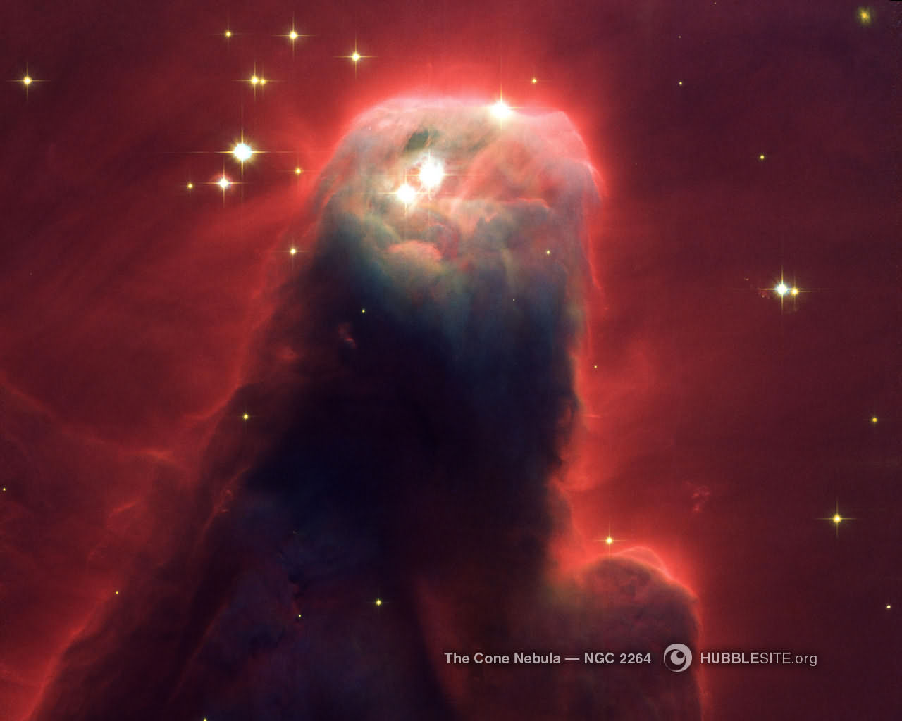

The Cone Nebula coded in Red

God divided day from night and so there was an evening and a morning the first day. Let there be light-I took the Reflection nebula where there is darkness and one light shining through the nebula. It is as if this was the creation of new light out of darkness. It is difficult when reading the Genesis creation account to visualize the creation of light. I thought that this Reflection nebula portrayed on a much smaller celestial scale the creation of light in darkness on the first day of creation.

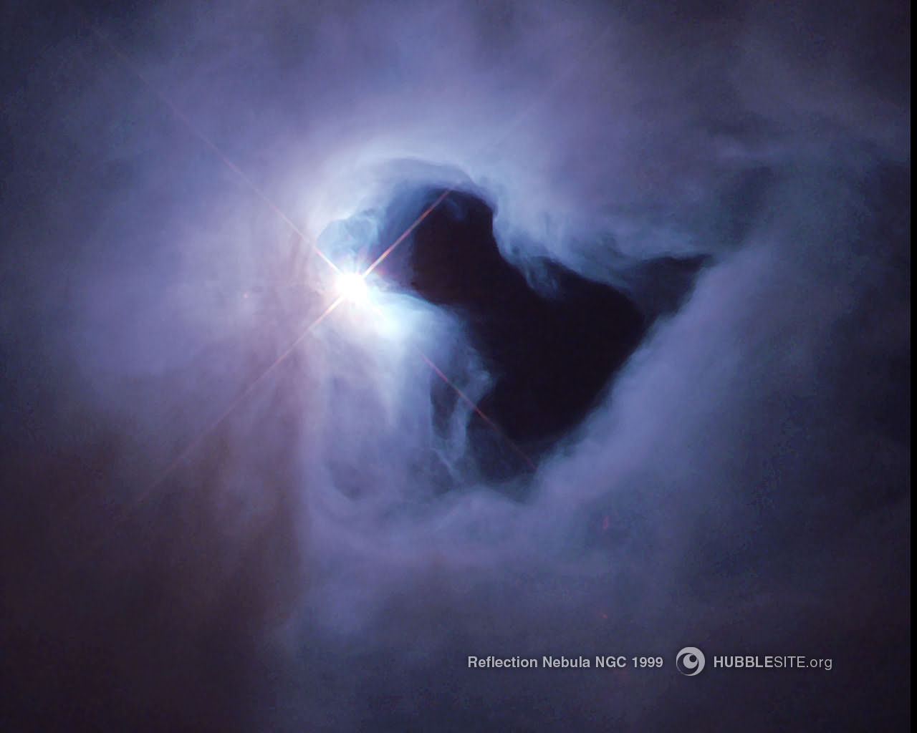

Reflection Nebula-Light Shining out of Darkness

Then the Second day of creation, "Then God said, 'Let there be a firmament in the midst of the waters," Into the midst of this amorphous matter, evidently like waters, God puts an expanse or firmament which divide the water mass above from the water mass below. There are two sections of water divided by the firmament, the waters above and the waters below the firmament, so now there is an orientation up and down. “And God called the firmament heaven. So there was an evening and a morning the second day.” You notice our order for the day, morning and evening, here is inverted? In the Jewish celebration of days, they begin at 6 oclock in the evening. The Sabbath begins on Friday at 6 oclock, they keep the order in the Genesis creation account, so it is an evening and a morning, one day. This is the second day.

Third Day. "Then God said, "Let the waters under the heavens (now he's taking the waters that are below the firmament and that are gathered together in one place and let the dry land appear; and it was so. And God called dry land earth and the gathering together of the waters, he called seas. And God saw that it was good." To describe His creation, God generally pronounces the creation of the day as "good” or “very good.” Do you know what God means by pronouncing the daily creation as good or very good? God means that His creation is perfect. The original creation in Genesis had perfection at its conception. Naturalism had nothing in the beginning, no matter and no energy. Then the universe appears out of nothing in a chaotic state and starts increasing in order and complexity. The creationist view of the universe is exactly the opposite. There was perfection at the creation, the beginning of the universe. That perfect creation is now going to go the other way-from perfection to total disorder.

But as the Genesis recounts history, the original creation was perfect at the very beginning, it was good. "Then God said, 'Let the earth bring forth grass, the herb that yields seed, and the fruit tree that yields fruit according to its kind whose seed is in itself, on the earth’; and so it was. And the earth brought forth grass, the herb that yields seed according to its kind and the tree that yields fruit whose seed is according to its kind." God creates the speciation in this third day. He makes everything according to its kinds. When there are distinct species, the species do not crossbreed with other species. God saw that the division of plant life into species was good; so it was an evening and a morning for the third day. Isn't that beautiful? God called the dry land earth. See, it appears out of the waters below. God said, “Let the earth bring forth the herb.” On the third day, the earth brought forth plant life-grass, herb and the tree.
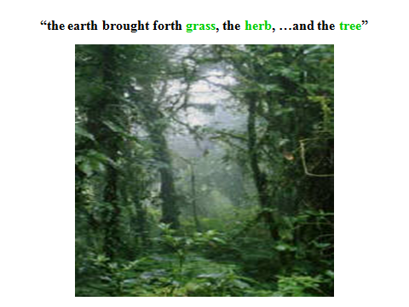

Fourth day, "Then God said, let there be lights in the firmament of the heavens to divide the day from the night; and let them be for signs and seasons, and for days and years.” And in verse 15, “And let them be for lights in the firmament of the heavens to give light on the earth; and it was so. Then God made two great lights: the greater light to rule the day, and the lesser light to rule the night. He made the stars also. God set them in the firmament of the heavens to give light on the earth and to rule over the day and over the night, and to divide the light from the darkness. And God saw that it was good. So then the evening and the morning was the fourth day.” Isn't this beautiful? Look at the following photos of these luminaries in the heavens.

Let there be lights in the firmaments of the heavens. Do you realize the amount of power it would take to create something like that? We live off just a small remnant of what our sun produces, which is a star. The earth only received about one billionth of the energy that our sun radiates. It requires more energy than our sun will give off in its entire lifetime in order to collect the matter and energy of our sun together, not even counting the energy required to bring the sun into existence. Look at the beauty of these celestial bodies in the photos above. Are not they beautiful? What colors, what brilliance, what sublimity, what composition? God’s supernatural artistic beauty in creation matches His immense supernatural power in creation.

The fifth day. Then God said, "let the waters abound with an abundance of living creatures and let the birds fly across the earth, across the face of the firmament of the heavens". In other words, you have the sea creatures in the water, and you have birds in the air flying across the face or the lower side of the firmament. So God created great sea creatures and every living thing that moves with which the waters abound according to their kind again and every winged bird according to its kind. And God saw that it was “good,” again “good.” And God blessed them, saying, "Be fruitful and multiply, and fill the waters in the seas, and let the birds multiply on the earth. So the evening and the morning was the fifth day."

So God created the great sea creatures. These are two whales in the photo below. A whale is an amazing animal. It is a mammal. breathing air as a creature of the deep ocean. Some of them get up to 200 tons, moving through the water at 30 miles an hour. Unbelievable!

So God created every winged bird.

The sixth day of creation. Then God said, “let the earth bring forth living creatures according to its kind.” These are the land animals: “cattle and creeping things and beasts of the earth each according to its kind and it was so and God made the beasts of the earth according to its kind.” Remember, God in this Genesis creation account wears this term out, “according to its kind.” He wants to make it very clear to us that he made these things as distinct species. “Cattle according to its kind, and everything that creeps on the earth according to its kind. And God saw that it was good," again good. I don't like creeping things, but God made them good at the beginning. I always wondered, What is the purpose of mosquitoes, ants, especially biting ants, and bees, especially killer bees? I have been hit and stung by killer bees and what was so good about that? But in the beginning, they were made good.

Also on the sixth day, God said, "Let us make man in our image" You know why this is so interesting? Because, in Hebrew the word for God is a plural, Elohim. Elohim generally takes a singular verb. But here in the biblical creation text, He uses plurals with Elohim, plural verbs and first person plural pronouns. In very rare uses of plurals, God uses Elohim with plural verbs and first person plural pronouns (“us” and “our”) when referring to Himself. “Let us,” first person plural pronoun, “make,” plural verb, “in our (first person plural pronoun) image.” Is God talking to angels or other pre-creation beings? The angels, nor any other being, played no part in the creation. Men and angels are created in the image of God and are both called the sons of God but men are not created in the image of angels.

No, God is talking to Himself, the triune One that is/are creating. So in these very first passages of Scripture, God is teaching about His triune nature-Father, Son, and Holy Spirit. You remember the Spirit of God hovering over the waters in the second verse of the whole Scriptures? Here on the sixth day of creation, God is saying We, the members of the Godhead are creating together. This creation passage is very difficult to accept if you do not believe in the Triune God. There are other passages in Genesis where God uses plural verbs and plural first persons of Himself. These Genesis passages of God referring to Himself in the plural may be the only biblical instances where this happens. This use by God of referring to Himself in the plural is very stunning especially in these beginning events of the universe, recorded in Genesis.

"Let us make man in our image," in other words, man is the son of God- he's created in the image of God. “According to our likeness,” each human is someone important with the image of God written all over. It is also seen in angels, referred to as sons of God, and from description in other portions of the Scripture the angels look like us for the most part. So, from images of God in the prophecies of Isaiah, Ezekiel, and the Revelation, God looks like us. No man has ever seen the face of God. However, God’s hands, torsos, legs, and feet, although they have different colors, look like ours. A deer is not cast in the image of God, neither is a favorite dog. I don't have any favorite cats, but no cats are created in the image of God. Even monkeys which look similar to men do not bear the inner spiritual nature of God. In the person of Jesus Christ we see the perfect man, reflecting God’s image perfectly.

So God created man in his own image, in the image of God He created man as male and female. Then, God blessed them and God said to them be fruitful and multiply, fill the earth and subdue it. He did not make two men nor two women as His image. God made a man and a woman in His image. That does not go very well with our common political correctness over homosexuality. But, God originally gave man dominion over the fish of the sea, over the birds of the air, and over the cattle and over all the earth and over every creeping thing that creeps on the earth. In our day of political correctness, this does not fit exactly right. Political correctness says that we humans are just one of them and yet they protect a baby whale over a baby human. Neither does political correctness accept God giving man dominion over His creation. If the truth were to be told, the political correct world does not even believe that God exists or that God created the universe. The political correct culture has lost all understanding of God and His designs in creation.

God has more designs for the creation on the sixth day. God said in talking to the man, "See, I have given you every herb that yields seed which is on the face of the earth and every tree that yields seed to you it shall be for food." In other words, man is given the right to eat vegetables, but not meat at this point of time. "And also to every beast of the earth, every bird of the air, and everything that creeps on the earth in which there is life. I have given the green herb for food and it was so."

The lions do not have to eat other animals to live. They can live on grass. Every carnivore is an omnivore and it can be exclusively a herbivore. The animal kingdom was created to live solely on plants. There was not the tooth and claw viciousness in the original creation. The animals were given the right to eat herbs and grass and fruit in the original creation. Bears eat berries; they do not have to eat fish. Bears do not have to eat people; they can survive very well on plants. Things had changed since the original creation. There was a man who had been attacked by a shark, it had taken part of his side out. Fortunately, someone got there before he bled to death. He said later, "I realize I was part of the food chain, but I wasn't at the end of it. I got caught in the middle.” But that was not the way God originally created animals. Sharks were made to live only on green vegetables.

Then, God saw everything that He had made in the whole creation and indeed it was very good. This is the sixth day, and so it was an evening and a morning was the sixth day. In this very good, perfect creation at the end of six days, God had animals eating plants and man had dominion over the plants and animals.

But that perfect creation would be ruined by its master, man. I have some Russian friends who served in the Arctic Circle in the days of the Cold War. Their greatest enemy there was not the United States or the arctic blizzards. It was one of God’s creatures, the polar bears. In the winter time, these bears do not sleep; they do not hibernate; they just hunt and eat. My friends lost some of their comrades to these bears. The polar bears would sit out there in a blizzard for days near their camp with their paws covering their noses because that is the only dark part of their bodies. As the soldiers were going between their quonset huts, the polar bear would seize the armed soldier and eat him, leaving only his gun. But that was not the way God in His perfect creation intended the polar bears to live, eating man, God’s designated master over the creation.

The seventh day. “And on the seventh day God ended the work which he had done and he rested on the seventh day from all of his work which he had done. Then God blessed the seventh day and he sanctified it because in it he rested from all of the works which he had created and made.” So on the seventh day the creation of the universe is finished. God finished His creation work and designates the seventh day as His day of rest. Look at these beautiful things, there are beauties out there in the universe which we have never seen, because we can't see that far. You know we can not even see stars in other galaxies unless they blow up.

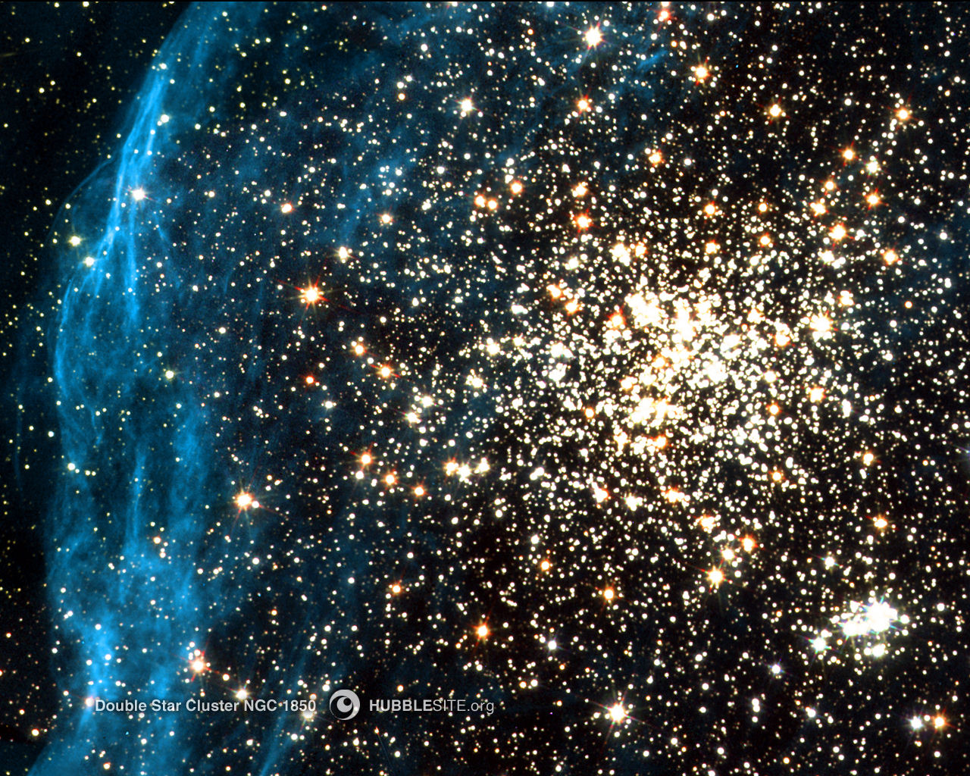

But these are some stars we can see in our own galaxy, the Milky Way. Are not they beautiful? These stars not only just a creation; they are a work of art, done on a scale that none of us can ever imagine.

Let us make some observations about the creation. The creation in Genesis 1-2 breaks into eternity. Before the creation of the universe there was total silence and quietness from eternity past in time. All of a sudden the creation of the universe breaks into eternity. Genesis 1-2 is interpreted as a historical narrative using a historical grammatical hermeneutics (method of interpretation). The historical text of Genesis 1-2 is unlike Psalms 104 which is the creation events in a poetic form. In the scriptures there are different types of literature-historical narratives, poetry, prophecies, wisdom literature, parables, and allegories. But each type of literature has its own method of interpretation.

Genesis 1-2 is a historical narrative and requires an historical grammatical hermeneutics (method of interpretation). Genesis 1-2 is not any other type of biblical literature such as prophesy, parables, types, proverbs, allegories, antecdotes, or doctrinal teaching. Moreover, it is not a nonbiblical type of literature called myths. There are no myths in the bible contrary to what some people might say, "Well this is just a myth." Frankly, there are no myths anyplace in the Bible. There are historical narrative, there are prophecies, there are poetries, there are doctrinal teachings, but there are no myths. Genesis 1-2 is an historical account of the Creation.

The Creation account in Genesis 1:2-2:3 is one of several histories in Genesis. These histories are called toledoths in Hebrew in Genesis. Toledoth is an interesting word. In Genesis 1:2 through Genesis 2:3 all of the verses begin with the waw consecutive, connecting the verses together as one history the six days of creation and the seventh day of rest. Then Genesis 2 verse 4 gives an explanatory note that this whole Genesis 1:2-2:3 creation account is one of the toledoths (histories) of Genesis, "This is the history (toledoth) of the creation of the heavens and the earth.” "Toledoth" comes from the word "to create" as humans would do, or even beget. Its root meaning is “generations” and can mean (1) a history generated by someone or (2) a genealogy of someone. In Genesis toledoth is sometimes translated as genealogies but most uses of toledoth do not involve genealogies such as here in Genesis 1. It appears the use of toledoth in Genesis shows that Moses under the divine inspiration of the Holy Spirit has collected in a chronological series of histories (toledoths). The Genesis toledoths are historical accounts either transmitted verbally or actually written down. Toledoths are histories of events or people.

In this seventh day Creation toledoth (history) had no human observer until the end of the last day who could tell or write this Creation history. So this Genesis toledoth was probably given to Adam, in this case by God, and Adam told his descendents this toledoth in either a verbal or written history. It is obvious from Adam’s ability to name all of the animals and not to forget their names that Adam and his more immediate descendents had perfect memories. The memory retention must have continued for many generations after Adam until Moses. This is apparent because (1) no written Scriptures were needed until Moses and (2) complex hieroglyphic written languages were used until the simplified alphabetic languages based on phonetics were used by Moses to write the first Holy Scriptures. By the time of Moses, the great retention in memory beginning with Adam was being lost. This loss of memory in the human race continues to our present day and is due to genetic entropy. Most people today can hardly memorize a single passage of Scripture without great effort.
Genesis, written by Moses, is a collection of these histories (toledoth), not just Genesis 1:2-2:3. "This is the history of the heavens and the earth when they were created." "This is the history of Adam." "This is the history of Noah." "This is the history of Abraham.” Toledoth is used about eleven times in the book of Genesis and are preexisting histories which Moses collected and put them together under divine inspiration. In other words, Moses was not working like a prophet, receiving these histories solely by divine revelation with no previous historical information or documents. God could have given Genesis to Moses much like God did to the prophets about events in the future. But it appears that God by divine guidance used preexisting toledoths for Moses to write the book of Genesis. If God can give a prophet 20/20 vision into the future, He could certainly guide Moses in using preexisting histories which Moses acknowledges as source toledoths to give a 20/20 history of the past in Genesis.

More observations on the creation account can be made. The first acts of creation were that matter came out of nothing. That is so stunningly supernatural because the universe can not create one atom. In fact, you know what is incredible? With all of our laboratories, we can't even create one carbon atom out of electrons and protons. "I'll give a scientist the electrons and the protons, let him produce a carbon atom for me.” Don't you find that stunning? But even more stunning is that we certainly can not create that out of nothing electrons and protons from scratch. But, God not only creates carbon atoms He can create them out of nothing. God has created the whole universe as atoms, not just carbon atoms, out of nothing not out of pre-existing electrons and protons!!

This Creation of matter in the universe was followed by something even more spectacular than creating the whole universe out of nothing. God then ordered the atoms of the universe into incredible celestial systems all at the same time!! We look around at the celestial bodies in the universe and we see novas and supernovas. The novas and supernovas are going boom, boom, boom, boom, around us in a uniform pattern in every direction. We're looking at the fourth of July going off in celestial bodies every few days. Look at this photo of the Crab nebula which exploded in a supernova in 1054 AD and was seen by Arab, Chinese, and Japanese astronomers.

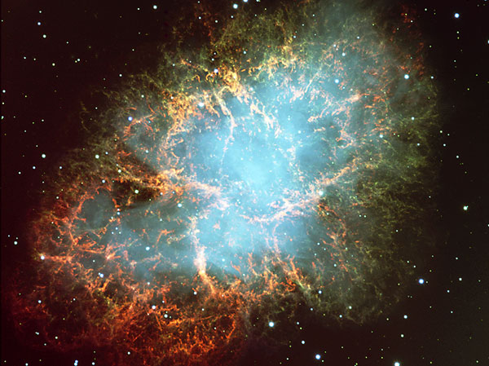

Crab Nebula as the Residue of a Supernova Explosion

The uniform distribution of these celestial explosions indicates that the celestial bodies which are exploding all started about the same time and they are all burning out at the same rate. Contrary to the theories of secular cosmologists, these celestial bodies because of their uniform distribution of novas throughout the universe must have comes into being at the same time and in a very short amount of time apart. This is one of the premises of the Big Bang theory. Also, the creation must have included not only matter but the energy such as light as well. Free energy (not in the atomic structures of matter) is basically electromagnetic radiation. Electromagnetic waves or radiation can be light but it can be in lower energy forms such as radio and microwaves or it can even be in higher energy forms such as x-rays, gamma rays, or cosmic rays. The universe began as a perfect order, as God said "good and very good." However, the universe is becoming less perfect every day. Yesterday, there was a better universe than today. Tomorrow, the universe will be worse than today as the stars and galaxies continuously burned up and exploded. The universe started off as good and perfect. God only took 6 daily stages to make the universe perfect.

Yom is the Hebrew word used in Genesis 1 for day. Yom always means a 24 hour day in Hebrew when each day (1) has an evening and a morning and (2) has a number with the day: 1 day, 2 days, 3 days. Yom can in some cases can mean a longer period of time, like the “day of the Lord”, or in “the day that the Lord created the heavens and the earth.” But yom never means more than a 24 hour day when it is used with an evening and a morning nor when it is used with a number.

God created (bara) an orderly universe at the very beginning of the universe from disordered matter in six days, contrary to the assertions of modern cosmology’s upward evolution of the universe to its present order over billions of years. God did not finish creating the universe until the sixth day. The Creation was not complete, man was not there, nothing was complete until the sixth day and then the creation of the universe was finished. The sequence and the time frames of the events in Genesis 1 and 2 do not follow evolutionary schemes of the naturalists. In the Genesis the plants are created before the sun, moon, and stars. Fish and other aquatic animals including the whales (great creatures of the deep) are created before the land animals. But how can whales which are mammals exist before land animals? According to the evolutionary scheme the predecessors to whales came up on the land, becoming mammals, and then returned back into the water to develop into whales. The Genesis creation do not follow the evolutionary sequence schemes. Also, the Genesis creation do not follow modern cosmological schemes because you have light in the universe before you have stars and planets and the moon.

Let’s make some other observations about the creation. This Genesis account is not a framework hypothesis which does not believe in the literal 7 creation days of 24 hours less than 7,000 years. However, in a orderly way God creates domains for life and then creates the creature to occupy those domains. The first three creation days are couplets of the second three creation days. In the first three days God creates three domains. Then in the second three days God creates the occupants who will occupy these three domains. For instance, the first day God creates the domain of light in the universe. On the fourth day, God created the celestial lights to occupy the light domain in the universe. The second day, God separated the waters by a firmament. On the fifth day God created the water animals to occupy the waters domain and He created the birds flying across the firmament to occupy the firmament domain. The third day God created dry land domain. Remember He called the land out of the water? And the dry land domain is given the plant kingdoms. On the sixth day God created the land animals, including man, to occupy the dry land domain full of the plant kingdom.

By the way, there is a symbiotic relationship (mutually beneficial) between plants and animals. Animals can not live without plants. The whole metabolisms of plants and animals are different which makes their symbiotic relationship vital for their mutual survival. Plants take in carbon dioxide from the air and put back out oxygen into the atmosphere. In an opposite metabolism animals take in oxygen from the air and put back carbon dioxide into the atmosphere. And the plants and animals work together to maintain a good atmospheric environment. Also, we and other animals can not eat rocks, drink water, and live. We do not have the ability to take advantage of the sun's energy but the plants do have that ability with photosynthesis, producing food which animals can eat. Using the sunlight, the plants grow from inorganic rocks, water, and soil so that we can eat plants as food and we can live. God was very clever when He created the plants before He does any of the animals.

One last observation is very important. Jesus and the writers of the New Testament verify that Genesis 1-11 is a young universe history. Jesus is the Divine Creator as explained in John 1, “all things were made by Him, and there was nothing made that He did not create. Jesus as the Creator verifies the creation of Adam and Eve. He says, "from the beginning of creation God made them male and female." Jesus is treating Adam and Eve as real people in history. Jesus also verifies the historicity in people in Genesis such as this passage about Adam and Eve in Matthew 24. Other New Testament books treat Moses as history. Luke in the same manner as Genesis 5 and 11 traces the genealogy of Jesus to Adam who is also called the son of God since Adam has no progenitor. These genealogies show that the creation less than 7,000 years old. Paul built his major theology on the historical Adam such as Romans 5 and I Corinthians 15, "for by one man sin entered the world and death through sin.” Sin enters the created universe through the first Adam in these passages. But who is the second Adam that Paul speaks of? The second Adam of course is Jesus, the one who is going to release the universe from the sin and the curse incurred by the first Adam. Other Old Testament people and events in Genesis and other books of Moses are referred to as being historical such as II Peter.

Important Observation: Are Jesus (the Creator), Luke, Peter, and Paul lying about the historicity of events and people in Genesis? Or do they speak of Genesis as true history a relatively short time ago?

